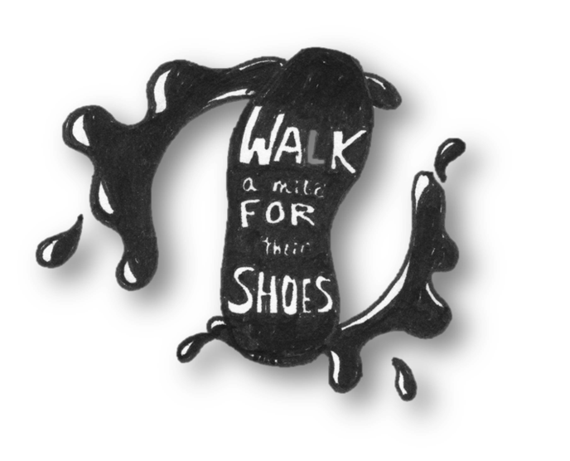
Walk a Mile for Their Shoes
May 12th @ 1pm
@ Western Boone track

Walk a Mile for Their Shoes is a Color Run/ Walk open to all ages. There will also be an activity course to complete if you so choose. The activity course will includes things such as egg on a spoon race, three legged race, and sponge races, tug a war, etc. You will register in teams of four and the fee is one new or lightly used pair of shoes per team for an elementary age boy or girl. We encourage as many donation as you can give. All donations will be distributed to local elementary students in need of shoes. To complete you registration please make sure you bring the following suggested items and have completed the following forms:
- Group registration form (please bring copy with you to event just in case)
- Disclaimer for children under 18
- Shoe Donations (required one pair per team)
- Googles/ eye protection (highly recommended and will not be provided)
- Lawn chairs (if want to take breaks)
- Water (if you would like you own but water will be provided)
When you have completed these forms you can email them to Megan Dickey at dickeymegan13@gmail.com. We ask that you title the subject Walk a Mile for Their Shoes- Team Name. We will use the email that you use to submit to the registration to contact you if necessary. On behave of the Kiwanis Global Leadership Class of 2017 thank you for your participation and hope to see you May 14th. If you have any further question you can contact Susan Farris at susan.farris@webo.k12.in.us
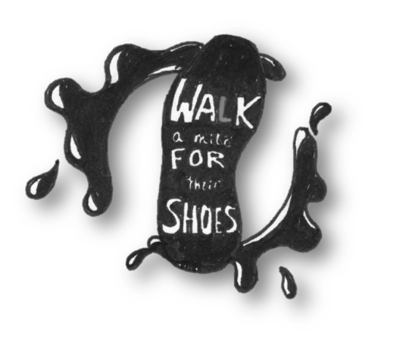
WHEN: May 14 @ 1pm (this could change but we hope to keep it within a three hour time period)
WHERE: Western Boone Jr.-Sr. High School (report to area by the tennis courts)
FEE: Donate one pair of shoes for an elementary age student (if you can we encourage more!)

*please return to Western Boone High School or email to Susan Farris by Wednesday May 12th
Walk a Mile for Their Shoes
Group Name: .
*if multiple groups of four for one organization/ group please include a number with the group names (ex. Power Team #1, Power Team #2)
Number of Shoe Donations: .
Will your team be participating in the activity course? Yes or No
Does your team have multiple children 7th grade or younger? Yes or NO
If yes please give an adult that will be present the day of the events and contact information:
Name Phone # .
Do you have children under 18 that will be participating? Yes or NO
If so all children under 18 put have a consent form signed by both themselves and a parent.
*if multiple groups of four for one organization/ group please include a number with the group names (ex. Power Team #1, Power Team #2)
 | NAME of Participant | AGE | Group Affiliation (youth group, business, school club, etc)
1.
2.
3.
4.
*If you have any further question please contact Susan Farris at susan.farris@webo.k12.in.us or Megan Dickey at dickeymegan13@gmail.com
**One form for each participant under the age of 18 must be filled out and turned in with the registration**

I,. .(print participant name) do hereby agree to abide by all the rules and regulations set forth by the Junior Leadership Team. I am responsible for providing my own eye protection (goggles or glasses). I, also by signing this form, hereby waive and release any and all rights and claims for any damages I may have against Western Boone Jr. Sr. High School, sponsors of this club, and any other employee of said school, for any injuries arising from my participation.

_______________________________________
Participant Signature

I, , (print parent name), do hereby give my consent for my student’s participation in this event. I, also by signing this form, hereby waive and release any and all rights and claims against Western Boone Jr. Sr. High School, sponsors of this club, and any other employee of said school, for damages incurred by said student that might be a direct or indirect outgrowth of his or her participation in this event.

_______________________________________
Parent’s Signature

_______________________________________
Cell Phone #

_______________________________________
Date

