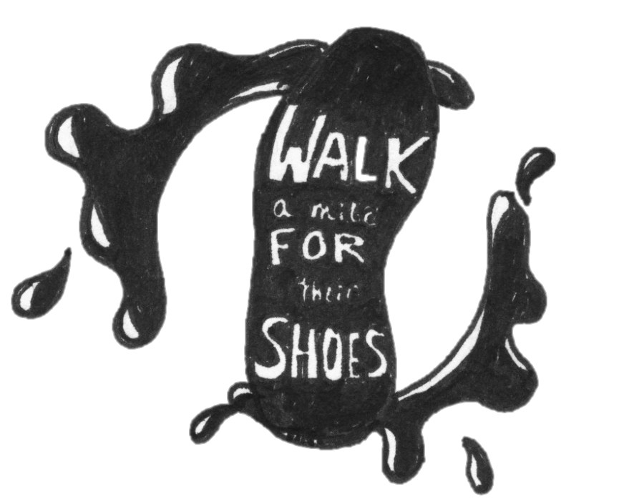
Western Boone 11 Kiwanis Leadership Team
“Walk A Mile for Their Shoes”
Color Walk
@ Western Boone Track
Saturday, May 14th @ 1:00 p.m.
“Walk A Mile for Their Shoes” is one COLORFUL event where all ages can come have fun, get exercise, and donate shoes to our local children in need from Western Boone District!
Fee: At least 1 pair of shoes per team
**rain date May 15th @ 2:00 p.m.

Contact Susan Farris at susan.farris@webo.k12.in.us
with any question and for registration forms visit webo.weboschools.org

