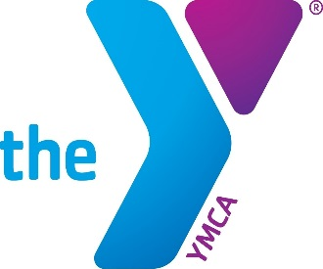Witham Family YMCA Scholarship Application

Applicant Name: _________________________________________________________Date of Birth:_____________________
Address: _______________________________________________________ City: _______________________ Zip:_____________
Email Address: __________________________________________ Phone #: __________________________________________
Name of High School:__________________________________________ GPA:_____________ Class Rank:____________
Name(s) of College You Plan To Attend: ___________________________________________________________________
Degree and College Major If Known: ________________________________________________________________________
Your Current career plan falls under which of the following areas of focus:
Youth Development: ____________ Healthy Living: ____________ Social Responsibility: _______
Career Plan Summary:
______________________________________________________________________________________________________________________________________________________________________________________________________________________________________________________________________________________________________________________________________________________________________________________________________________________________________________________________________________________________________________________________________________________________________________________________________________________________________________________________________________________________________________________________________________________________________________________________________________________________

Names of Parents or Guardians: Father: ______________________ Mother: ____________________________
Legal Resident of Boone County (please circle): YES NO

Extra-Curricular Activities:
________________________________________________________________________________________________________________________________________________________________________________________________________________________________________________________________________________________________________________________________________________________________________________________________________________________________________________________________________________________________________________________________________________________________________________________________________________________________________________________________________________________________________________________________________________________________________________________________________________________________________________________________________________________________________________________________________________
Community Service Activities:
__________________________________________________________________________________________________________________________________________________________________________________________________________________________________________________________________________________________________________________________________________________________________________________________________________________________________________________________________________________________________________________________________________________________________________________________
Honors & Awards:
__________________________________________________________________________________________________________________________________________________________________________________________________________________________________________________________________________________________________________________________________________________________________________________________________________________________________________________________________________________________________________________________________________________________________________________________
Work Experience:
__________________________________________________________________________________________________________________________________________________________________________________________________________________________________________________________________________________________________________________________________________________________________________________________________________________________________________________________________________________________________________________________________________________________________________________________

Non-Relative References:
1. Name: _______________________________________________ Phone: ____________________________
2. Name: _______________________________________________ Phone: ____________________________

*Please send your transcript and application for the scholarship to:
Witham Family YMCA
Attn: Kim Newnam, Executive Director
2791 N Lebanon St.
Lebanon, IN 46052

**All applications must be received by April 12, 2020

